Title (font size:12) - This is the Title Section – Use Title Case
¹First Author, ²Second Author, ³Third Author
¹Email 1(Corresponding Author’s Email), ²Email 2, ³Email 3
School, City, State, Country

Abstract – Upload your files via Submission Portal on the www.jyem.org or by email.(200~220 words, font size:10, font style: Times New Roman) This document is a template for the submission of your research paper. Please submit the application form as well. Your research project documents and application form can be submitted via the online system or via email (directly) as attachments to info@jyem.org
Keywords: One, two, three, four, five (at least 5 keywords are required)

Introduction
This template provides (font size:12, font style: Times New Roman) authors with most of the formatting specifications needed for preparing electronic versions of their papers. The author must fill in the information form under the “SUBMISSION PORTAL” tab at JYEM.org, and upload relevant documents. The Reference List needs to be appeared at the end of your paper and provides the full citations for all the references you have used.[1] Margins are 1 inch on all sides and the font is Times New Roman.

Any Subtitle(s)
Define abbreviations and acronyms the first time they are used in the text, even after they have been defined in the abstract. Do not use abbreviations in the title or heads unless they are unavoidable [2].
You will need to determine whether or not your equation should be typed using either Times New Roman or the Symbol font (please, no other fonts). To create multilevel equations, it may be necessary to treat the equation as a graphic. Equation numbers, within parentheses, are to be flushed right, as in (1), using a right tab stop.
x+y+z = 3 (1)
Note that the equation is centered using a center tab stop.

Figure captions should be below the figures; table heads should appear above the tables. Insert figures and tables after they are cited in the text.

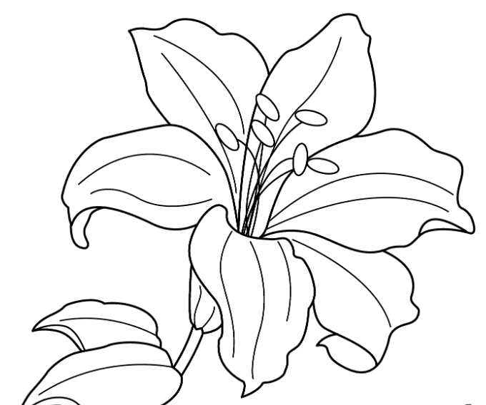
Figure 1. Example of a figure caption. (clear image is recommended)

Table 1. This is the Table 1
Table Column Head
Subhead | Subhead | Subhead
cell | cell | cell

Figure and Table Labels: Use 10-point Times New Roman for the Figure and TABLE labels. Use words rather than symbols or abbreviations when writing Figure axis labels to avoid confusing the reader.

Discussion and Conclusion
A conclusion section is not required if your paper is under the category of “Work in Progress”. Although a conclusion may review the main points of the paper, do not replicate the abstract as the conclusion. A conclusion might elaborate on the importance of the work or suggest applications and extensions.

Acknowledgments (Optional)
I would like to express my deepest appreciation to all those who provided me with the possibility to complete this project. A special gratitude I give to our final year project teacher(researcher), [Ms/Mr/Dr. Surname]...

References (Either MLA or APA format is fine)
- Please include min. 5 References. List all references in the order they've been cited within the paper. Please refer to: https://pitt.libguides.com/citationhelp/overview for the citations style.
- G. O. Young, “Synthetic structure of industrial plastics (Book style with paper title and editor),” in Plastics, 2nd ed. vol. 3, J. Peters, Ed. New York: McGraw-Hill, 1964, pp. 15–64.
- W.-K. Chen, Linear Networks and Systems (Book style). Belmont, CA: Wadsworth, 1993, pp. 123–135.
- H. Poor, An Introduction to Signal Detection and Estimation. New York: Springer-Verlag, 1985, ch. 4.
- Please include min. 5 References

